https://rdsnakes.blogspot.com/2023/10/rd-snacks-shop.html

[RD snacks](https://rdsnakes.blogspot.com/?m=1)

# RD snacks shop

[October 11, 2023](https://rdsnakes.blogspot.com/2023/10/rd-snacks-shop.html?m=1)

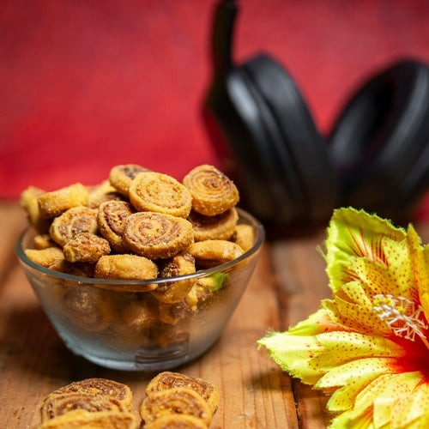

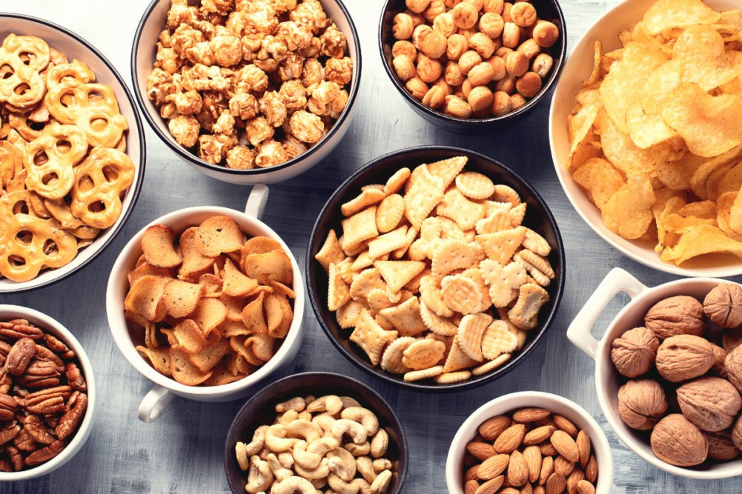

Many people enjoy eating between meals. Snacks can be part of a healthy eating pattern.

They can help you get important nutrients, keep you energized and satisfy your hunger between meals.

# Tips for Healthy Snacking

Plan for snacks in advance. Add healthy snack foods to your grocery list

Stock your fridge, freezer and pantry with healthy foods that you can grab quickly. Some examples include:

Fresh fruits and vegetables Frozen fruit

Fruits canned in water or their own juice Whole grain bread, crackers and cereals Lower fat yogurt

Lower fat cheese

Unsalted nuts and seeds and their butters Hummus

Hard boiled eggs

Single serving canned ﬁsh

Include a vegetable or fruit with each snack. Wash vegetables and fruit ahead of time so they are quick and easy to grab when you are hungry. Cut up vegetables and store them in smaller containers in the fridge

Pack snacks in your bag for when you are on the go. Travel friendly ideas include roasted chickpeas, nuts and seeds, and fruit such as apples, oranges and bananas Pack small portions of leftovers and use them as snacks. After meals, package leftovers into smaller “snack” sized containers, date and label the containers, and store them in the fridge or freezer

Be mindful when you snack. Take time to eat and notice when you are hungry and when you are full

Eat without distractions, put electronics away and focus on enjoying eating

Try not to eat straight from large packages or containers. Portion out a smaller amount instead

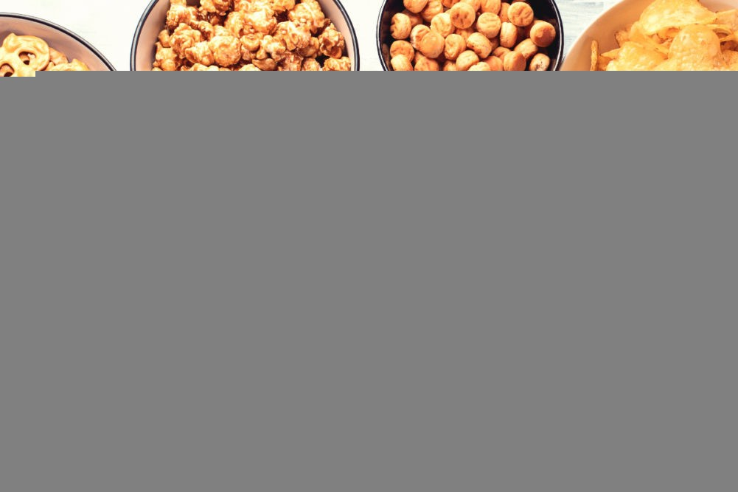Stay hydrated throughout the day. You can sometimes mistake hunger for thirst. Make water your drink of choice

# Healthy Snack Ideas

Snacks can be both healthy and satisfying. Snacking can be as simple as grabbing an apple, a handful of nuts or a bowl of popcorn. Here are some snack ideas that are more ﬁlling. All of these snacks include a fruit or a vegetable.

Fresh or frozen berries with cottage cheese Banana slices with peanut butter

Fresh fruit skewers with Greek yogurt

Canned fruit such as peaches or pears with yogurt Apple slices topped with almond butter or cheese Peaches with soft tofu

Unsweetened applesauce sprinkled with cinnamon and toasted nuts or seeds Yogurt and chopped fresh fruit sprinkled with nuts or granola

Homemade wholegrain blueberry muﬃn

Apple berry crisp with a dollop of Greek yogurt

Whole grain English muﬃn with almond butter and fruit slices Homemade smoothie or lassi

Blend together fruit and/or vegetables with yogurt, milk or unsweetened fortiﬁed soy beverage



Homemade trail mix

Mix together dried whole grain cereal, unsweetened dried fruit, nuts or seeds Chia pudding with unsweetened shredded coconut and pineapple

Frozen yogurt popsicle

Blend together fruit and yogurt, then pour into popsicle mold tray and freeze Energy bites made with dates and nuts

High ﬁbre cereal topped with chopped fruit and milk or fortiﬁed soy beverage Cut up vegetables with hummus or a yogurt-based dip such as tzatziki

Green leafy salad with sliced strawberries and toasted almonds Celery sticks or cucumber rounds topped with tuna salad

Veggie sticks with cashew dip

Bean and corn dip with pita chips